Annex C

Thomas Telford Multi Academy Trust

Redhill Primary Academy


Attendance Policy

Prepared by: Sir Kevin Satchwell

This policy summarises the expectations required from all Schools/Academies within Thomas Telford Multi Academy Trust (TTMAT). Further details are contained in the DfE Statutory Guidance, Working Together to Improve School Attendance published 29 February applicable from 19 August 2024. The Guidance should be read in conjunction with this Policy.
Extract from Statutory Guidance applicable from 19 August 2024
Working together to improve attendance
Successfully treating the root causes of absence and removing barriers to attendance, at home, in school or more broadly requires schools and local partners to work collaboratively in partnership with, not against families. All partners should work together to:
Expect
Aspire to high standards of attendance from all pupils and parents and build a culture where all can, and want to, be in school and ready to learn by prioritising attendance improvement across the school.
Monitor
Rigorously use attendance data to identify patterns of poor attendance (at individual and cohort level) as soon as possible so all parties can work together to resolve them before they become entrenched.
Listen and understand
When a pattern is spotted, discuss with pupils and parents to listen to and understand barriers to attendance and agree how all partners can work together to resolve them.
Facilitate support
Remove barriers in school and help pupils and parents to access the support they need to overcome the barriers outside of school. This might include an early help or whole family plan where absence is a symptom of wider issues.
Formalise support
Where absence persists and voluntary support is not working or not being engaged with, partners should work together to explain the consequences clearly and ensure support is also in place to enable families to respond. Depending on the circumstances this may include formalising support through an attendance contract or education supervision order.
Enforce
Where all other avenues have been exhausted and support is not working or not being engaged with, enforce attendance through statutory intervention: a penalty notice in line with the National Framework or prosecution to protect the pupil’s right to an education.

The Law and day to day processes
Parents have a legal duty to ensure that their child attends school regularly.
There is a strong link between persistent absence and crime.
The law requires that all schools must have an admission register.
Appropriate national attendance and absence codes must be used.
Schools/Academies should only grant leave of absence under exceptional circumstances.
Lateness should not exceed 30 minutes.
Where possible Schools /Academies should hold more than one emergency contact number.
Statutory returns to the LA and DfE must be complied with.
All schools must have an electronic management information system which can be accessed by the DfE.

As a minimum what leaders, staff, pupils, and parents need to understand:
- It should be made clear to all parties that attendance and punctuality, expectations of pupils and parents, including start and close of the day, register closing times and the processes for requesting leave of absence and informing the school of the reason for an unexpected absence are appropriately followed.
• All Schools/Academies should appoint a Senior Attendance Officer.
• All Schools/ Academies should provide contact details of the school staff who pupils and parents should contact about attendance. It is sensible to have a triage system to facilitate for more detailed support where appropriate for complex cases.
• Day to day processes for managing attendance, for example first day calling and processes to follow up on unexplained absence should be in place for all schools/Academies.
• How to incentivise good attendance.
• Data to target attendance improvement should be readily available for teachers’, leaders, and Governors.
• All School/Academies should provide a strategy for reducing persistent and severe absence, including how access to wider support services will be provided to remove the barriers to attendance and when support will be formalised in conjunction with the local authority.
• Details of the National Framework for Penalty Notices and when Notices to Improve, penalty notices or other legal interventions will be sought if support is not appropriate (e.g. for a holiday in term time), not successful, or not engaged with.

TTMAT and Local Governing Boards
All trusts and governing bodies are expected to:
• Recognise the importance of school attendance and promote it across the school’s ethos and policies.
• Ensure school leaders fulfil expectations and statutory duties.
• Regularly review attendance data, discuss, and challenge trends, and help school leaders focus improvement efforts on the individual pupils or cohorts who need it most.
• Ensure school staff receive adequate training on attendance.
Multi-academy trust boards and governing bodies of federations are also expected to:
- Share effective practice on attendance management and improvement across schools.
- Monitor attendance patterns.

Local Authority (LA)and Safeguarding Partnerships
The LA and safeguarding partnership have a key role to play regarding attendance.
They are facilitators of wider support. They should provide a minimum support service and be used to support schools. They should have a support team, offer advice, provide family support and if needed take legal action.
It is important that all our schools have a clear understanding of what service the LA can provide and what their expectations are from the schools.
The LA must provide each school with a named point of contact in the School Attendance support team. Each school must know the contact details of the named contact.
The LA can apply legal intervention to support schools where appropriate including issuing penalty notices or prosecute.
The LA can provide additional support services and help families which in turn can impact on school attendance.
LAs should communicate with each other when working with cross border pupils.
Persistent and severe absence
Targeted support should be in place for pupils who miss 10% or more of school.
Appropriate services should work together to ensure that those pupils with less than 50% attendance should be given top priority.
Where partners are unable to impact upon severe absences a full social care assessment should be conducted in line with Keeping Children Safe in Education.

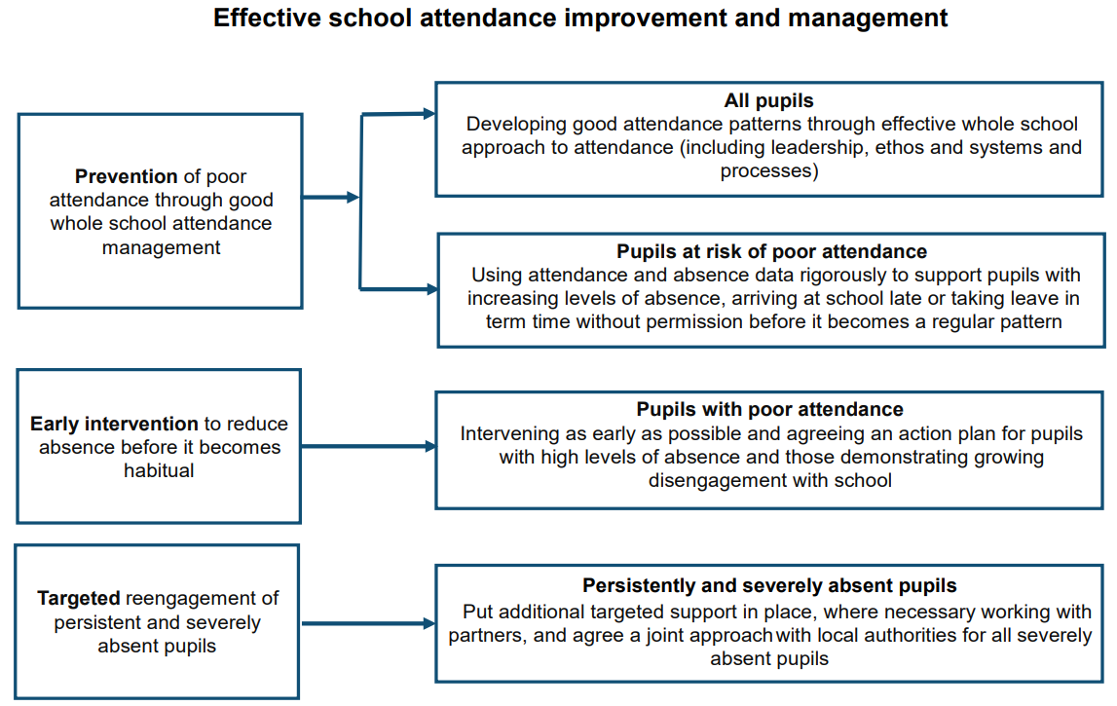
Extract from Statutory Guidance

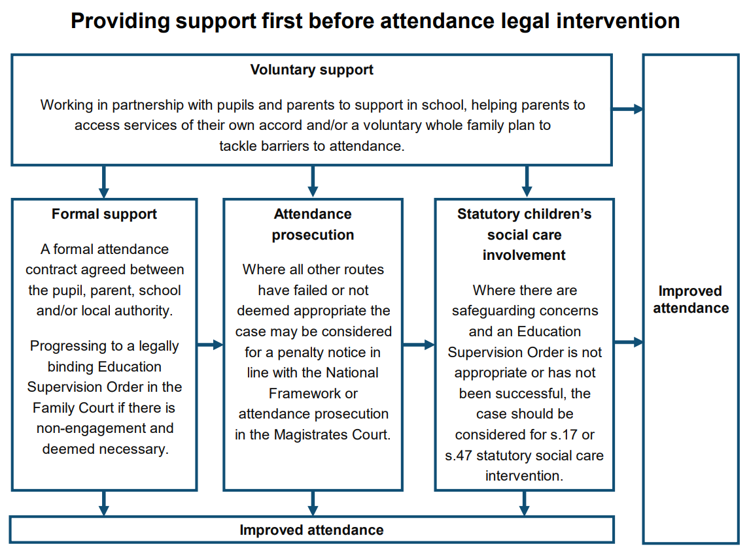
Extract from Statutory Guidance

Further details in relation to contracts, Education Supervision Orders (ESO), prosecutions, parenting orders and penalty notices are contained in Statutory Guidance paras 134 to 200.
Headteachers, Safeguarding leads and Senior Attendance officers appointed by Academies should familiarise themselves with legal intervention strategies and ensure that appropriate data is shared regularly with Governors.
Admissions Register
The school admission register must be kept in accordance with the School Attendance (Pupil Registration) (England) Regulations 2024. The admission register must be kept electronically.
Deletion of names
Where a school notifies the local authority that a pupil’s name is deleted from the admission register, the school must provide the local authority with the following information about the pupil from the admission register:
• full name;
• address;
• the full name and address of any parent the pupil normally lives with;
• at least one telephone number by which any parent the pupil normally lives with can be contacted in an emergency;
• if applicable, the pupil’s future address, the full name and address of the parent who the pupil is going to live with, and the date the pupil will start living there.
Off-rolling without following the appropriate procedure, which includes informing the LA must not happen.
All Schools/Academies must follow the updated use of registration codes as follows.
Extract from DfE Statutory Guidance
Code / \: Present at the school / = morning session \ = afternoon session 286. Pupils must not be recorded as present if they are not in school during registration. If a pupil were to leave the school premises after registration, they will still be counted as attending for statistical purposes.
Code L: Late arrival before the register is closed 288. All schools are expected to set out in their attendance policy the length of time the register will be open, after which a pupil will be marked as absent. This should be the same for every session and not longer than 30 minutes. If a pupil is marked N but arrives later in the session after the register has closed, the attendance register must be amended to mark them as absent using code U.
Code K: Attending education provision arranged by the local authority 290. The pupil is attending a place, other than the school or any other school at which they are a registered pupil, for educational provision arranged by a local authority.
A pupil attending provision arranged by the school rather than the local authority must be recorded using Codes P or B instead. 291. Schools must also record the nature of the provision, examples are: • attending courses at college; • attending unregistered alternative provision such as, home tutoring.
Code V: Attending an educational visit or trip. The pupil is attending a place, other than the school.
Code P: Participating in a sporting activity. The pupil is attending a place for an approved educational activity that is a sporting activity.
Code W: Attending work experience. The pupil is attending a place for an approved educational activity that is work experience provided under arrangements made by the school as part of the pupil’s education.
Code B: Attending any other approved educational activity. The pupil is attending a place for an approved educational activity that is not a sporting activity or work experience.
Code D: Dual registered at another school. The law allows a pupil to be registered at more than one school. This code is used to indicate that the pupil is absent with leave to attend the other school at which they are registered. The main examples of dual registration are pupils who are attending a pupil referral unit, a hospital school or a special school on a temporary basis. The school at which the pupil is scheduled to attend must record the pupil’s attendance and absence with the relevant code. Code D may only be used by either school for a session where the pupil is scheduled to attend the other school at which they are registered. Schools should ensure that they have in place arrangements whereby all unexpected and unexplained absences are promptly followed up.
Code C1: Leave of absence for the purpose of participating in a regulated performance or undertaking regulated employment abroad. All schools can grant leaves of absence for pupils to undertake employment (paid or unpaid) during school hours. Schools should be sympathetic to requests for leave of absence that are supported by a licence issued by a local authority or a BOPA; as long as the school remains satisfied that this will not have a negative effect on a pupil’s education. It is at the discretion of the school to grant leave of absence.
Code M: Leave of absence for the purpose of attending a medical or dental appointment.
Code J1: Leave of absence for the purpose of attending an interview for employment or for admission to another educational institution.
Code S: Leave of absence for the purpose of studying for a public examination Schools maintained by a local authority and special schools not maintained by a local authority can grant leave of absence for a pupil to study for a public examination and the leave has been agreed in advance with a parent who the pupil normally lives with (or the pupil if they will be over compulsory school age by the time of the absence).
Code X: Non-compulsory school age pupil not required to attend school.
Code C2: Leave of absence for a compulsory school age pupil subject to a part-time timetable. All pupils of compulsory school age are entitled to a full-time education. In very exceptional circumstances, where it is in a pupil’s best interests, there may be a need for a temporary part-time timetable to meet their individual needs. This requires a start and finish date of any agreement and should be short term.
Code C: Leave of absence for exceptional circumstances. All schools are able to grant a leave of absence at their discretion. A leave of absence must not be granted unless there are exceptional circumstances.
Code T: Parent travelling for occupational purposes.
Code R: Religious observance. The pupil is absent on a day that is exclusively set apart for religious observance by the religious body the parent(s) belong to (not the parents themselves). The school may only record one day using this code; the rest of the time would need a leave of absence, and this is granted at the school’s discretion as set out under Code C.
Code I: Illness (not medical or dental appointment). The pupil is unable to attend due to illness (both physical and mental health related).
Code E: Suspended or permanently excluded and no alternative provision made. The pupil is suspended from school or permanently excluded from school, but their name is still entered in the admission register, and no alternative provision has been made for the pupil to continue their education. When a pupil of compulsory school age is suspended or permanently excluded on disciplinary grounds from a maintained school, pupil referral unit, academy, city technology college, or city college for the technology of the arts, alternative provision must be arranged from the sixth consecutive school day of any suspension or permanent exclusion. Where alternative provision is made for the session in question and the pupil is attending it, schools should record this using the appropriate attendance code, or if the pupil is attending another school at which they are a registered pupil, schools should record this using code D (dual registered at another school).
Code Q: Unable to attend the school because of a lack of access arrangements.
Code Y1: Unable to attend due to transport normally provided not being available.
Code Y2: Unable to attend due to widespread disruption to travel.
Code Y3: Unable to attend due to part of the school premises being closed.
Code Y4: Unable to attend due to the whole school site being unexpectedly closed
Code Y5: Unable to attend as pupil is in criminal justice detention.
Code Y6: Unable to attend in accordance with public health guidance.
Code Y7: Unable to attend because of any other unavoidable cause. An unavoidable cause, that is not covered by one of the other ‘unable to attend’ codes detailed above, is preventing the pupil from attending the school. This code should be used only where something in the nature of an emergency has prevented the pupil from attending the session in question.
Code G: Holiday not granted by the school.
Code N: Reason for absence not yet established 393. Schools must follow up all unexplained and unexpected absence in a timely manner. Every effort should be made to establish the reason for a pupil’s absence.
If a reason for absence cannot be established within 5 school days, schools must amend the pupil’s record to Code O. 395. This code is classified for statistical purposes as unauthorised absence.
Code O: Absent in other or unknown circumstances.
Code U: Arrived in school after registration closed.
Code Z: Prospective pupil not on admission register. To enable schools to set up registers in advance of pupils joining the school to ease administration burdens.
Code #: Planned whole school closure.

Other relevant legislation and guidance
The Education Acts 1996 and 2002
The Children Act 1989 The Crime and Disorder Act 1998
The Anti-Social Behaviour Act 2003
The Education and Inspections Act 2006
The Sentencing Act 2020
The School Attendance (Pupil Registration) (England) Regulations 2024
The Education (Parenting Contracts and Parenting Orders) (England) Regulations 2007
The Education (Penalty Notices) (England) Regulations 2007, as amended The Education (Information about Individual Pupils) (England) Regulations 2013
The Children and Young Persons Acts 1933 and 1963
The Equality Act 2010
Relevant government guidance
Children missing education
Keeping children safe in education and Working together to safeguard children Special educational needs and disability code of practice: 0 to 25 years
Elective home education
Alternative provision: statutory guidance for local authorities
Exclusion from maintained schools, academies and pupil referral units in England
Supporting pupils at school with medical conditions
Arranging education for children who cannot attend school because of health needs
Promoting and supporting mental health and wellbeing in schools and colleges
Preventing and tackling bullying Providing remote education.

Addendum 1

Redhill Primary Academy believes that to facilitate teaching and learning, good attendance is essential. Pupils cannot achieve their full potential if they do not regularly attend school.
We understand that barriers to attendance are complex, and that some pupils find it harder than others to attend school; therefore, we will continue to prioritise cultivating a safe and supportive environment at school, as well as strong and trusting relationships with pupils and parents.
We take a whole-school approach to securing good attendance and recognise the impact that our efforts in other areas – such as the curriculum, behaviour standards, bullying, SEND support, pastoral support, and the effective use of resources such as pupil premium – can have on improving pupil attendance.
We are committed to:
- Promoting and modelling high attendance and its benefits.
- Ensuring equality and fairness for all.
- Ensuring this attendance policy is clear and easily understood by staff, pupils and parents.
- Intervening early and working with other agencies to ensure the health and safety of our pupils.
- Building strong relationships with families to overcome barriers to attendance.
- Working collaboratively with other schools in the area, as well as other agencies.
- Ensuring parents follow the framework set in section 7 of the Education Act 1996, which states that the parent of every child of compulsory school age shall cause them to receive efficient full-time education suitable to their age, ability and aptitude, and to any SEND they may have, either by regular attendance at school or otherwise.
- Ensuring our attendance policy is clear and easily understood by all staff, parents and pupils.
- Regularly monitoring and analysing attendance and absence data to identify pupils or cohorts that require more support.

The Nominated Attendance Person (NAP) is Amy Steele and she can be contacted via parentcontact@redhillprimary.co.uk Staff, parents and pupils will be expected to contact the NAP for queries or concerns about attendance. For more detailed support on attendance please contact Zara Bate on the email above. Our school’s Senior Attendance Champion is Lydia Cartwright.

Addendum 2

Roles and Responsibilities

The Head of School is responsible for:
- The day-to-day implementation and management of this policy and all relevant procedures across the school.
- Appointing a senior member of staff to the attendance role.
- Ensuring all parents are aware of the school’s attendance expectations and procedures.
- Ensuring that every pupil has access to full-time education and will act as early as possible to address patterns of absence.
- The overall strategic approach to attendance in school.
Staff are responsible for:
- Following this policy and ensuring pupils do so too.
- Ensuring this policy is implemented fairly and consistently.
- Modelling good attendance behaviour.
- Using their professional judgement and knowledge of individual pupils to inform decisions as to whether any welfare concerns should be escalated.
- Where designated, taking the attendance register at the relevant times during the school day.
The Nominated Attendance Person (NAP) is responsible for:
- Developing a clear vision for improving attendance.
- Monitoring attendance and the impact of interventions.
- Analysing attendance data and identifying areas of intervention and improvement.
- Communicating with pupils and parents/carers regarding attendance.
- Leading a compassionate approach when listening to parents/carers and pupils regarding barriers to attendance.
- Following up on incidents of persistent poor attendance.
- Enforcing attendance through statutory interventions in cases of persistent poor attendance where other supports have not succeeded.
- Informing the LA of any pupil being deleted from the admission and attendance registers.
Pupils, at the appropriate age, are responsible for:
- Attending their lessons and any agreed activities when at school.
- Arriving punctually to lessons when at school.
- Following any support provided by the school to improve attendance.
Parents/carers are responsible for:
- Providing accurate and up-to-date contact details.
- Providing the school with more than one emergency contact number.
- Updating the school if their details change.
- The attendance of their children at school.
- Promoting good attendance with their children.
- Proactively engaging with any attendance support offered by the school and the LA.
- Notifying the school as soon as possible when their child has to be unexpectedly absent.
- Requesting leave of absence only in exceptional circumstances, and in advance.
- Booking any medical appointments around school where possible.
- Following any family-based support implemented by the school to improve attendance.

Addendum 3
Definitions
The following definitions apply for the purposes of this policy:
Absence:
- Arrival at school after the register has closed.
- Not attending the registered school for any reason.
Authorised absence:
- An absence for sickness for which the school has granted leave.
- Emergency medical or dental appointments which unavoidably fall during school time, for which the school has granted leave.
- Religious or cultural observances for which the school has granted leave.
- An absence due to a family emergency.
Unauthorised absence:
- Parents keeping children off school unnecessarily or without reason.
- Truancy before or during the school day.
- Absences which have never been properly explained.
- Arrival at school after the register has closed.
- Absence due to shopping, looking after other children or birthdays.
- Absence due to day trips and holidays in term-time which have not been agreed.
- Leaving school for no reason during the day.
Persistent absence (PA):
- Missing 10 percent or more of schooling across the year for any reason.

Addendum 4
The Academy Day
Breakfast Club  8am – 8.40am  7.45am – 8.40am | Breakfast Club for registered children only.  - 8am-8.40am Nursery and Reception Breakfast Club  - 7.45am-8.40am Years 1, 2, 3, 4, 5 and 6
School Office  8.30am | The office is open daily from 8.30am.
8.40am until  8.50am | Doors open for children to enter the building.  Registration complete.
8.50am | Start of day.
8.51am onwards | Late children will enter school via the main reception entrance, where their parents will sign them in. The Admin Team will address persistent lateness.
10.10am -10.25am | KS1 Break time
10:25am – 10:40am | KS1 Assembly  KS2 Break time
10.40am-11.00am | KS2 Assembly
Lunchtime | Reception 11.55am-12.55pm,  Year 1 and Year 2 12 -1pm,  KS2 12.05pm – 1pm.
1pm | Afternoon registration.
Optional | KS1 may have an optional afternoon break at the discretion of the class teacher.
3.05pm for Reception  3.10pm for Year 1,2,3,4, 5,6 | End of the school day.  - All children from Reception to Year 4 to be handed directly to their parent/carer or known adult.  - Year 5 and 6 children can depart from the classroom independently but are reminded to come back into the Academy if the expected adult they are due to meet isn’t on the playground or in the agreed meeting place.  - Some Year 5 and 6 children may have permission to walk home which will be communicated to the class teacher by the office staff.  - Any child not collected after 10 minutes at the end of the Academy day should be taken to the office. An administrator needs to be informed that the child has not been collected. The parents/carers will be contacted so that pick up can be arranged.
Activity Clubs run until 4.05pm or 4.20pm as advised on timetable | - Run by teachers, TAs or external club providers.
Annexe After School Club  3.05pm or 3.10pm - 6pm | Annexe After school club for registered children only.  - 3.05pm or 3.10pm-4pm all children are in the Nursery building.  - 4pm-6pm Nursery and Reception children remain in the Nursery building.  - 4pm-6pm Years 1, 2, 3, 4, 5 and 6 children move to the hall.

The total time children are in school during the week is 32 hours 30 minutes (including breaks.)

Addendum 5

Absence Procedures

Parents/Carers will be required to contact the school office in person or via telephone (please leave a message on the answerphone) or by sending an email to parentcontact@redhillprimary.co.uk before 8:45am on the first day of their child’s absence – they will be expected to provide an explanation for the absence and an estimation of how long the absence will last, e.g. one school day. It is expected that parents/carers will contact the school on every day of their child’s absence.

Where a pupil is absent, and their parent/carer has not contacted the school by the close of the morning register to report the absence, administrative staff will contact the parent/carer by telephone call as soon as is practicable on the first day that they do not attend school. The administrative staff may also contact the other emergency contact details listed on the school’s MIS system.

The school will always follow up any absences in order to:
• Ascertain the reason for the absence.
• Ensure the proper safeguarding action is being taken.
• Identify whether the absence is authorised or not.
• Identify the correct code to use to enter the data onto the school MIS system.

The NAP may attend the pupil’s home to conduct a safe and well check on the pupil. These visits may be carried out whether the parent/carer has called to inform the school of the pupil’s absence or not. These visits will be unannounced. They may be carried out more than once during the pupil's absence if it is ongoing. Other agencies working with families such as strengthening family’s practitioners, social workers, etc may also be contacted to explore reasons for absences.

The school will not request medical evidence in most circumstances where a pupil is absent due to illness; however, the school reserves the right to request supporting evidence where there is genuine and reasonable doubt about the authenticity of the illness. If the school is not satisfied about the authenticity of the illness, the absence will be recorded as unauthorised, and parents/carers will be notified of this in advance and home visits may also be made.

If a pupil’s attendance drops below 92 per cent, an informal meeting will be arranged with the pupil’s parent/carer to discuss any barriers to a child’s attendance and early help strategies will be agreed to help improve attendance. If a pupil’s attendance drops below 90 per cent, a formal meeting will be arranged with the pupil’s parent/carer.

Where a pupil has not returned to school for 10 days after an authorised absence or is absent from school without authorisation for 20 consecutive school days, the school will remove the pupil from the admissions register if the school and the Local Authority have failed to establish the whereabouts of the pupil after making reasonable enquiries.
Addendum 6

Authorising Parental Absence Requests

Parents/carers will be required to request certain types of absence in advance. All requests for absence will be handled by the headteacher – the decision to grant or refuse the request will be at the sole discretion of the headteacher, taking the best interests of the pupil and the impact on the pupil’s education into account. The headteacher’s decision is not subject to appeal; however, the school will be sympathetic to requests for absence by parents/carers and will not deny any request without good reason.

Circumstances which could be authorised include funerals. However, parents/carers should be mindful that often it can also be beneficial to the child for them to remain in school. In these circumstances a proportionate, minimal time away from school is encouraged.

Leave of Absence

The school will only grant a pupil a leave of absence in exceptional circumstances. In order to have requests for a leave of absence considered, the school will expect parents/carers to complete a leave in term time form (available online or via email request) sent through to the school office, at least two weeks prior to the proposed start date of the leave of absence. A reason for the proposed absence and the dates during which the absence would be expected to occur must be detailed.

Any requests for leave during term time will be considered, by the Headteacher, on an individual basis and the pupil’s previous attendance record will be considered. Where the absence is granted, the headteacher will determine the length of time that the pupil can be away from school. The school is not likely to grant leaves of absence for the purposes of family holidays. Outcome letters will be sent to both natural parents confirming the decision, whether the parents live together or not. Stepparents will be included on correspondence.

Requests for leave will not be granted in the following circumstances:
- Immediately before and during statutory assessment periods
- When a pupil’s attendance record shows any unauthorised absence
- Where a pupil’s authorised absence record is already above 10 per cent for any reason

If term-time leave is not granted or a leave in term time form has not been completed, taking a pupil out of school will be recorded as an unauthorised absence and may result in sanctions, such as a penalty notice. The school cannot grant leaves of absence retrospectively; therefore, any absences that were not approved by the school in advance will be marked as unauthorised. A Penalty Notice can be requested when a pupil has accumulated 10 unauthorised sessions over a ten-week period, this includes all unauthorised absence and any leave not agreed by the school. The sessions do not have to be consecutive.

Please note: The Telford and Wrekin Code of Conduct also states: If in an individual case the local authority believes a Penalty Notice would be appropriate, they retain the discretion to issue one before the threshold is met. For example, when a parent purposefully tries to avoid a Penalty Notice by taking their child out of school when there is only four pupil days in school and the fifth day is for example a PD Day or bank holiday attached to that week.

Siblings

Where, in a particular case, there are siblings attending other schools, it is good practice and expected that those schools liaise with each other. However, it is for each school to make its own decision based upon the issues and circumstances relative to the pupil on their roll.

Illness and Healthcare Appointments

Parents/carers will be expected to make medical or dental appointments outside of school hours wherever possible. Where this is not possible, parents/carers will be expected to obtain approval for their child’s absence to attend such appointments as far in advance as is practicable. Parents/carers will be responsible for ensuring their child misses only the amount of time necessary to attend the appointment.

Year 6 Grammar School Tests

A morning or afternoon session will be authorised for Year 6 pupils to sit a grammar school test. If additional absence is taken, then this will be marked as unauthorised on the register.

Performances and Activities, including Paid Work

The school will ensure that all pupils engaging in performances or activities, whether they receive payment or not, which require them to be absent from school, understand that they will be required to obtain a licence from the LA which authorises the school’s absence(s).

Where a licence has been granted by the LA and it specifies dates of absence, no further authorisation will be needed from the school. Where an application does not specify dates, and it has been approved by the LA, it is at the discretion of the headteacher to authorise the leave of absence for each day. The headteacher will not authorise any absences which would mean that a pupil’s attendance would fall below 96 per cent. Where a licence has not been obtained, the headteacher will not authorise any absence for a performance or activity.

Religious Observance

Parents/carers will be expected to request absence for religious observance at least two weeks advance.

The school will only accept requests from parents/carers for absence on grounds of religious observance for days that are exclusively set apart for religious observance by the relevant religious body. The school will define this as a day where the pupil’s parents would be expected by an established religious body to stay away from their employment to mark the occasion.

The school may seek advice from the LA or religious body in question where there is doubt over the request.

Gypsy, Roma and Traveller absence

Where a pupil’s parent/carer belongs to a community covered by this code and is travelling for occupational purposes, the parent will be expected to request a leave of absence for their child at least two weeks in advance.

Absences will not be granted for pupils from these communities under this code for reasons other than travel for occupational purposes.

Addendum 7

SEND and Health-related Absences

The school recognises that pupils with SEND and/or health conditions, including mental health issues, may face greater barriers to attendance than their peers, and will incorporate robust procedures to support pupils who find attending school difficult.

In line with the SEND Policy and Supporting Pupils with Medical Conditions Policy, the school will ensure that reasonable adjustments are made for disabled pupils to reduce barriers to attendance, in line with any EHC plans or IHPs that have been implemented. The school will secure additional support from external partners to help bolster attendance where appropriate.
Where the school has concerns that a pupil’s non-attendance may be related to mental health issues, parents/carers will be contacted to discuss the issue and whether there are any contributory factors to their child’s lack of attendance. Where staff have a mental health concern about a pupil that is also a safeguarding concern, they will inform the DSL and the Child Protection and Safeguarding Policy will be followed. All pupils will be supported with their mental health in accordance with the school’s Social, Emotional and Mental Health (SEMH) Policy.

If a pupil is unable to attend school for long periods of time due to their health, the school will:
- Inform the LA if a pupil is likely to be away from the school for more than 15 school days.
- Provide the LA with information about the pupil’s needs, capabilities and programme of work.
- Help the pupil reintegrate at school when they return.
- Make sure the pupil is kept informed about school events and clubs.
- Encourage the pupil to stay in contact with other pupils during their absence.

The school will incorporate an action plan to help any pupils with SEND and/or health issues cope with the stress and anxiety that attending school may cause them. Such plans will be regularly monitored and reviewed until the pupil is attending school as normal and there has been signs of significant improvement.

To support the attendance of pupils with SEND and/or health issues, the school will consider:
- Holding termly meetings to evaluate any implemented reasonable adjustments.
- Incorporating a pastoral support plan.
- Carrying out strengths and difficulties questionnaire.
- Identifying pupils’ unmet needs through the Common Assessment Framework.
- Using an internal or external specialist.
- Enabling a pupil to have a reduced timetable.
- Ensuring a pupil can have somewhere quiet to spend lunch and breaktimes.
- Implementing a system whereby pupils can request to leave a classroom if they feel they need time out.
- Temporary late starts or early finishes.
- Phased returns to school where there has been a long absence.
- Small group work.
- Tailored support to meet their individual needs.

Addendum 8

Absent Pupils
Pupils will not be permitted to leave the school premises during the school day unless they have permission from the school. The following procedures will be taken in the event of a pupil going missing whilst at school:

- The member of staff who has noticed the absent pupil will inform the headteacher immediately
- The office staff will also be informed as they will act as a point of contact for receiving information regarding the search
- A member of staff will stay with the rest of the class, and all other available members of staff will conduct a thorough search of the school premises as directed by the headteacher
- The following areas will be systematically searched:
  - All classrooms
  - All toilets
  - The library
  - Any outbuildings
  - The school grounds
- Available staff will begin a search of the area immediately outside of the school premises and will take a mobile phone with them so they can be contacted.
- If the pupil has not been found after 10 minutes, then the parents/carers of the pupil will be notified
- The school will attempt to contact parents/carers using the emergency contact numbers provided
- If the parents/carers have had no contact from the pupil, and the emergency contacts list has been exhausted, the police will be contacted.
- The absent pupil’s teacher will fill in an incident form, describing all circumstances leading up to the pupil going missing
- If the absent pupil has an allocated social worker, is a looked-after child, or has any SEND, then the appropriate personnel will be informed
- When the pupil has been located, members of staff will care for and talk to the pupil to ensure they are safe and well
- Parents/carers and any other agencies will be informed immediately when the pupil has been located

The headteacher will take the appropriate action to ensure that the pupil understands they must not leave the premises, and sanctions will be issued if deemed necessary. Appropriate disciplinary procedures will be followed in accordance with the Behaviour Policy.

The headteacher will carry out a full investigation and will draw a conclusion as to how the incident occurred. A written report will be produced, and policies and procedures will be reviewed in accordance with the outcome where necessary.

Addendum 9

Attendance Intervention

To ensure the school has effective procedures for managing absence, the NAP, supported by the SLT, will:

- Establish a range of evidence-based interventions to address barriers to attendance.
- Monitor the implementation and quality of escalation procedures and seek robust evidence of the escalation procedures that work.
- Attend or lead attendance reviews in line with escalation procedures.
- Establish robust escalation procedures which will be initiated before absence becomes a problem by:
  - Sending letters to parents
  - Meeting with parents
  - Engaging with LA attendance teams
  - Using fixed penalty notices
  - Creating attendance clinics

The school will use attendance data, to develop specific strategies to improve attendance where patterns of absence are emerging. These strategies will be developed on a case-by-case basis and will consider the needs of the pupils whom the intervention is designed to target.

The school will acknowledge outstanding attendance and punctuality in the following ways:
- Assemblies
- Certificates
- Parent Communication – parents/carers consultations, new starter meetings
- Class rewards
- New starter packs

School trips and events will be considered a privilege. Where attendance drops below 90 per cent, these privileges may be taken away. The school will develop strategies for ensuring that pupils with health needs or home circumstances that result in additional absences are not unfairly excluded from attendance rewards, e.g. by setting individualised targets.

Addendum 10

Working with Parents to Improve Attendance

The school will work to cultivate strong, respectful relationships with parents/carers and families to ensure their trust and engagement. Open and honest communication will be maintained with pupils and their families about the expectations of school life, attendance and performance so that they understand what to expect and what is expected of them. The school will liaise with other agencies working with pupils and their families to support attendance, e.g. social services.

The school will ensure that there are two sets of emergency contact details for each pupil wherever possible to ensure the school has additional options for getting in touch with adults responsible for a pupil where the pupil is absent without notification or authorisation.

The school will ensure that parents are aware of their legal duty to ensure that their child attends school regularly and to facilitate their child’s legal right to a full-time education – parents/carers will be made aware that this means their child must attend school every day that it is open, save for in certain circumstances, e.g. sickness or absences that have been authorised by the headteacher in advance. The school will regularly inform parents/carers about their child’s levels of attendance, absence and punctuality, and will ensure that parents/carers are aware of the benefits that regular attendance at school can have for their child educationally, socially and developmentally.

If a pattern of absence becomes problematic, the NAP will work collaboratively with the pupil and their parents/carers to improve attendance by addressing the specific barriers that prevent the pupil from being able to attend school regularly. The school will always take into consideration the sensitivity of some of the reasons for pupil absence and will approach families to offer support rather than immediately reach for punitive approaches.

Where these barriers are related to the pupil’s experience in school, e.g. bullying, the NAP will work with the headteacher and any relevant school staff, e.g. the DSL and SENCO, to address this. Where the barriers are outside of the school’s control, e.g. they are related to issues within the pupil’s family, the NAP will liaise with any relevant external agencies or authorities, e.g. children’s social care or the LA, and will encourage parents/carers to access support that they may need.

Addendum 11

Persistent Absence (PA)

There are various groups of pupils who may be vulnerable to high absence and PA, such as:
- Children in need
- LAC
- Young carers
- Pupils who are eligible for FSM
- Pupils with EAL
- Pupils with SEND
- Pupils who have faced bullying and/or discrimination

Attendance expectations are high for all children. The school will use a number of methods to help support pupils at risk of PA to attend school.

These include but are not limited to:
- Offering catch-up support to build confidence and bridge gaps.
- Attendance support meetings to discuss patterns of absence, barriers to attendance, and any other problems they may be having with their child’s attendance.
- Leading weekly check-ins to review progress and the impact of support.
- Making regular contact with families to discuss progress.
- Assessing whether an EHC plan or IHP may be appropriate.
- Signposting in-school early help to explore the reasons for absence and to identify support needs i.e. pastoral support, ELSA.
- Offering a breakfast club place.
- Considering what support for re-engagement might be needed, including for vulnerable groups.
- Sending attendance letters detailing concerns.
- Signposting to the school nurse, if health is a concern.
- Completing an Early Help Assessment. Interventions such as this are considered on an individual case-by-case basis and will be undertaken in partnership with families.

Where a pupil at risk of PA is also at increased risk of harm, the school will work in conjunction with all relevant authorities, e.g. social services, to support the pupil in line with the school’s duty of care. The school will also bear in mind that the continuation of severe PA following intervention may constitute neglect and will escalate any concerns in this regard in line with the Child Protection and Safeguarding Policy.

Addendum 12

Penalty Notices and Legal Intervention

The school will endeavour to take a ‘support first’ approach to managing and improving attendance. Staff are keen to work with parents/carers to improve their child’s attendance. Early interventions for attendance are designed to be supportive and purposeful. The school will allow sufficient time for attendance interventions and engagement strategies to improve pupils’ attendance; however, where engagement strategies to improve attendance have not had the desired effect after one term, the NAP will consider:
- Working with the LA to put a parenting contract or an education supervision order in place.
- Engaging children’s social care where there are safeguarding concerns.
Where the above measures are not effective, the school and Local Authority will determine if further support could change the pupils’ attendance pattern. If it is deemed appropriate, the Local Authority will issue a Notice to Improve as a final opportunity for parents to engage in support and improve attendance before a penalty notice is considered. The Notice to Improve is intended as a warning to parents/carers. It allows between three and six weeks for parents/carers and pupils, if age appropriate, to work in partnership with the school to change behaviour and for the attendance to improve. If the attendance does not improve within the time identified in the Notice to Improve, a Penalty Notice will be issued. There will not be an opportunity for a parent/carer to receive a Notice to Improve if the unauthorised absence is caused by intended absence, e.g. an unauthorised family holiday.

The law protects pupils’ right to an education and provides a range of legal interventions to formalise attendance improvement efforts and, where all other avenues have been exhausted, enforce it through prosecuting parents.

Where a pupil reaches the national threshold of 10 sessions of unauthorised absence in a rolling period of 10 school weeks, the school will consider whether a penalty notice is appropriate. Each case will be considered individually to determine whether a penalty notice, or another tool or legal intervention should be used to improve attendance.

If in an individual case the local authority believes a Penalty Notice would be appropriate, they retain the discretion to issue one before the threshold is met. This might apply for example, when parent(s) are deliberately or purposefully avoiding the national threshold by taking several term time holidays below threshold, or for repeated absence for events such as birthdays and taking their child out of school, or when there are only four pupil days in school and the fifth day is for example a PD day or bank holiday.

A fixed penalty notice will be issued in line with the Local Authorities’ code of conduct and the DfE’s ‘Working together to improve school attendance’ guidance.

Penalty Notices for unauthorised absences are issued per parent/carer, per child for an accumulative 10 sessions of unauthorised absence over a 10-week period, (including leave in term time) as set out in the National Framework for Penalty Notices. The sessions do not need to be consecutive. The Penalty Notice fines will be charged at £160, reduced to £80 if paid within 21 days for the first Penalty Notice issued and £160 if paid within 28 days.

Any second Penalty Notice issued within three years to the same parent/carer for the same child will be at a flat rate of £160.

If absences continue within a three-year period of the first Penalty Notice being issued, alternative enforcement will be imposed.

Where attendance still does not improve following a fixed penalty notice, the school will work with the Local Authority to take forward attendance prosecution as a last resort.

Parents/carers who are prosecuted and attend court because their child has not been attending school may be fined up to £2,500.

An Exclusion Penalty Notice can be issued to parents/carers of a child of compulsory school age who is a registered pupil and is excluded for either a fixed period or permanently, as the parent/carer is guilty of an offence under Section 103 of the Education and Inspections Act 2006, if that child is present in a public place during school hours without reasonable justification during the first five days of each and every period of fixed or permanent exclusion.

Addendum 13

Monitoring and Analysing Absence

Our school has high expectations on attendance for all pupils. The NAP will monitor and analyse attendance data regularly to ensure that intervention is delivered quickly to address habitual absence at the first signs. Daily attendance analysis will be conducted by the NAP and sent through to the Headteacher daily.

The school will collect data regarding punctuality, and authorised and unauthorised absence, for:
- The whole school cohort.
- Individual year groups.
- Individual pupils.
- Demographic groups, e.g. pupils from different ethnic groups or economic backgrounds.
- Other groups of pupils, e.g. pupils with SEND, LAC and pupils eligible for FSM.
- Pupils at risk of PA.

The NAP will conduct a thorough analysis of the above data on a half-termly, termly and full-year basis to identify patterns and trends. This will include identifying, for each group:
- Patterns in uses of certain codes.
- Particular days of poor attendance.
- Historic trends of attendance and absence.
- Barriers to attendance.

The NAP will provide regular reports to staff across the school to enable them to track the attendance of pupils and to implement attendance procedures. The NAP will also be responsible for monitoring how attendance data changes in response to any interventions implemented to increase attendance in future.

The governing board will regularly review attendance data, including examinations of recent and historic trends, and will support the SLT in setting goals and prioritising areas of focus for attendance support based on this data.

The school will also benchmark its attendance data against local, and national-level data to identify areas of success and areas for improvement and will share practice which has been shown to be effective with other schools.

Monitoring and Review

Attendance and punctuality will be monitored throughout the year. The school’s attendance target is 97 per cent.

